Task 1:
.data
val1 DWORD 8000
.code
main PROC
mov eax, 0
mov eax, val1
add eax, 1
call dumpregs
exit
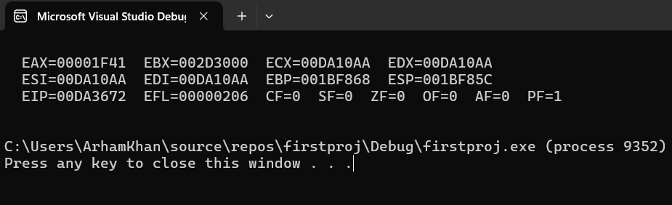
TASK 2:
.code
main PROC
mov eax, 0
mov ax, 7FF0h
add al, 10h ; a CF =1, SF =0, ZF =1, OF =0
add ah, 1 ; b CF =0, SF =1, ZF =0, OF =1
add ax, 2 ; b CF =0, SF =1, ZF =0, OF =0
call dumpregs
exit

TASK 3:
.data

array1 BYTE 61, 43, 11, 52, 25
array2 BYTE 5 DUP (?)
.code
main PROC
mov esi, offset array1 ; Point ESI to array1
mov edi, offset array2 ; Point EDI to array2
mov ecx, lengthof array1 ; Set loop counter to the length of array1

; Copy elements from array1 to array2
mov ebx, 0 ; Index for array2
copyLoop:
mov al, [esi + ebx] ; Load byte from array1 into AL
mov [edi + ebx], al ; Store byte from AL into array2
inc ebx ; Increment index
loop copyLoop

; showing array2 elements
mov esi, 0
mov ecx, 5
L2:
movzx eax, array2[esi]
call writedec
call crlf
inc esi
loop L2

call crlf

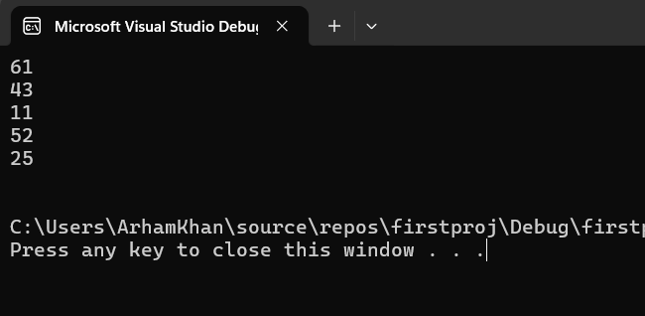
**Not able to sort the array2 in ascending order (need help in this).

TASK 4:
.data
arrayB byte 10, 20, 30
arrayW word 150, 250, 350
arrayD dword 600, 1200, 1800

sum1 dword ?
sum2 dword ?
sum3 dword ?

.code
main PROC

lea esi, arrayB ; same as writing: mov esi, offset arrayBmov edi, offset arrayW
mov ebx, offset arrayD

; for sum1
movzx eax, byte ptr [esi]
movzx edx, word ptr [edi]
mov ecx, [ebx]
add eax, edx
add eax, ecx
mov sum1, eax

; for sum2
movzx eax, byte ptr [esi + 1]
movzx edx, word ptr [edi + 2]
mov ecx, [ebx + 4]
add eax, edx
add eax, ecx
mov sum2, eax

; for sum3
movzx eax, byte ptr [esi + 2]
movzx edx, word ptr [edi + 4]
mov ecx, [ebx + 8]
add eax, edx
add eax, ecx
mov sum3, eax

mov eax, sum1
call WriteDec
call Crlf

mov eax, sum2
call WriteDec
call Crlf

mov eax, sum3
call WriteDec
call Crlf
